**If the fans are detected in Device Manager, but the corresponding control interface does not appear in L-Connect**

1. Please reinstall the latest version of L-Connect 3.
2. If you have already uninstalled and reinstalled the software but the issue persists:
   1. Disconnect the fan’s USB cable

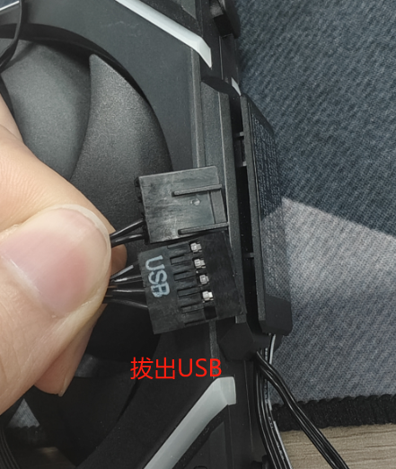

Unplug the USB cable

* 1. Clear the USB device history
     1. Please download the file and unzip it: <https://drive.google.com/file/d/1mlBsMDQ0J4302F5dK9XHcCLmMk2jmoLL/view?usp=sharing>
     2. 中國端下載位置: https://pan.baidu.com/s/1JAGh8tEar4ThhbkQNHR7GQ?pwd=p1y8 提取码: p1y8
     3. Run DeviceCleanup / Right Click > Run as Administrator

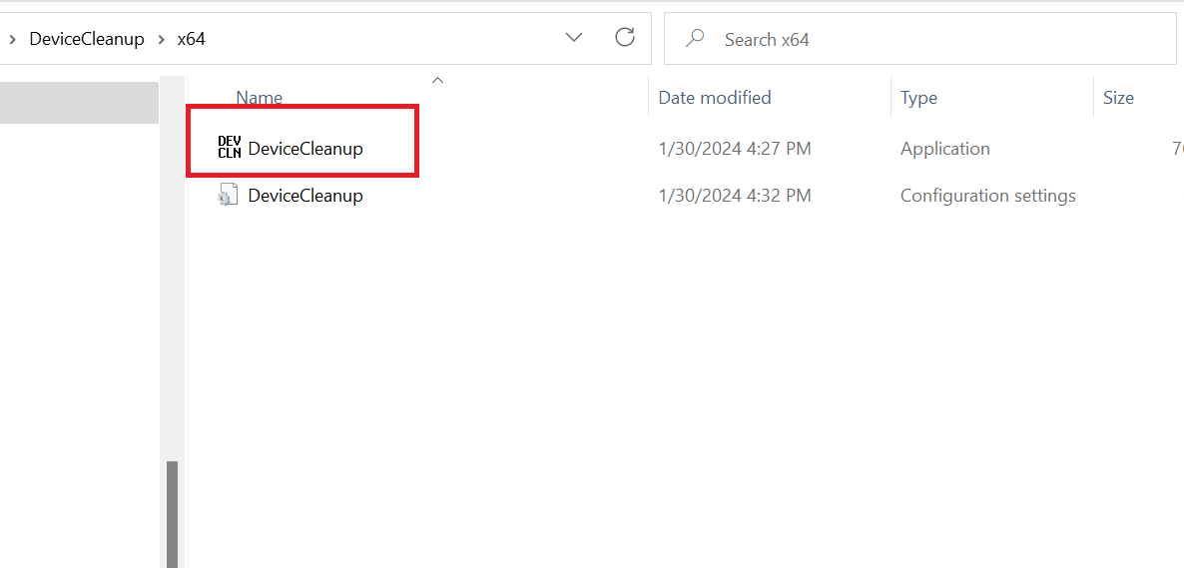

* + 1. Restart as administrator

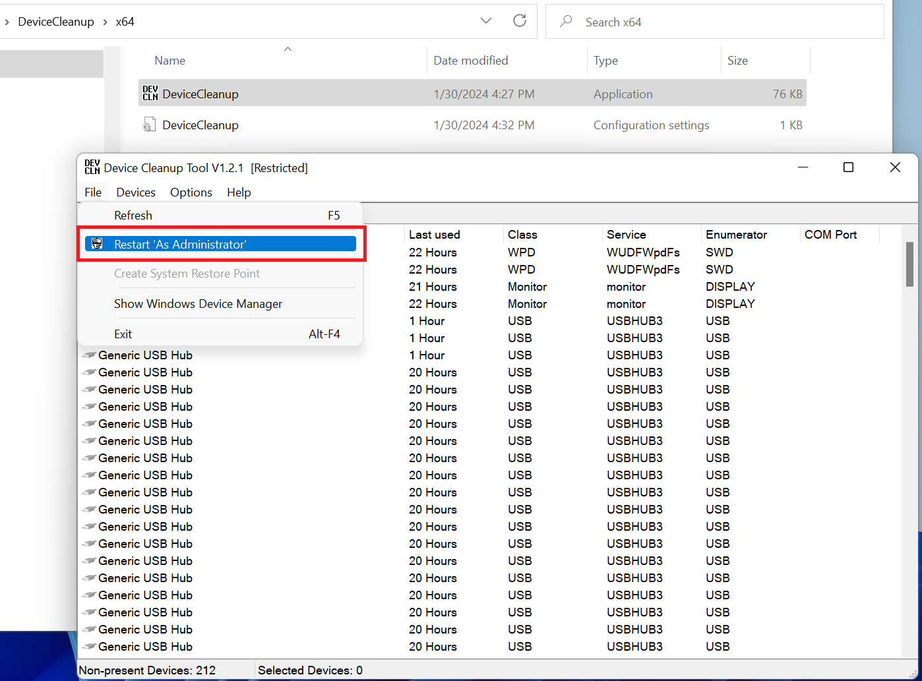

* + 1. Select all

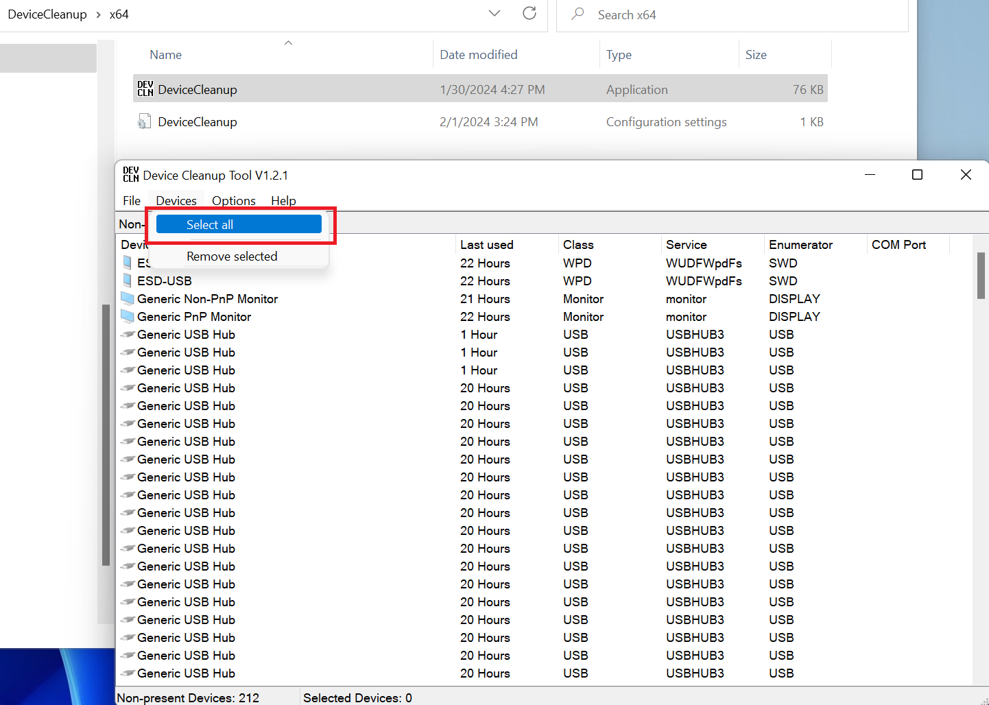

* + 1. Remove Selected

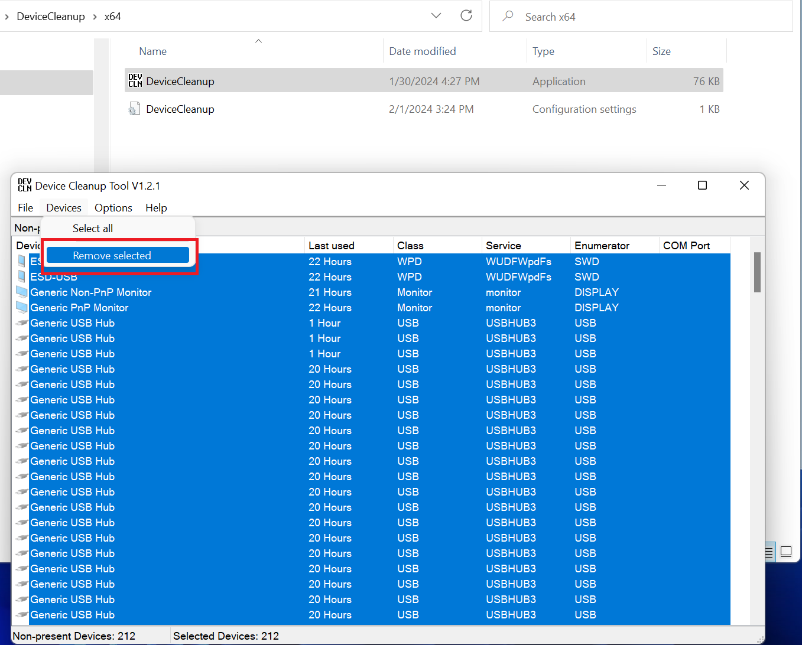

* 1. Shut-down the PC
  2. Reconnect the fan’s USB cable
  3. Power on the PC

1. At this stage, most users should be able to resolve the issue, but if the issue persists:
   1. Open Device Manager
   2. Located “Universal Serial Bus controllers”
   3. Locate the LCD fans

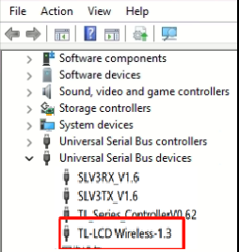

* 1. Right click and uninstall
  2. Open Windows Control Panel
  3. Go to Power Options-System Settings
  4. Disable Fast Startup

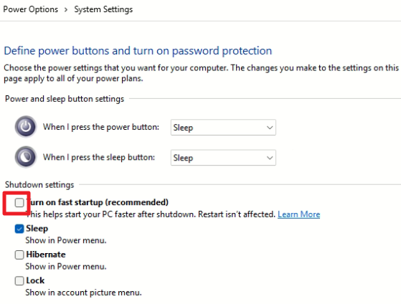

* 1. Power off the system, unplug the power supply, and wait until there’s no residual power. Then power on again to allow the USB device to be freshly recognized.