**Case: The fans are detected in Device Manager, but the corresponding control interface does not appear in L-Connect 3.**

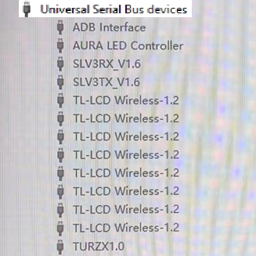

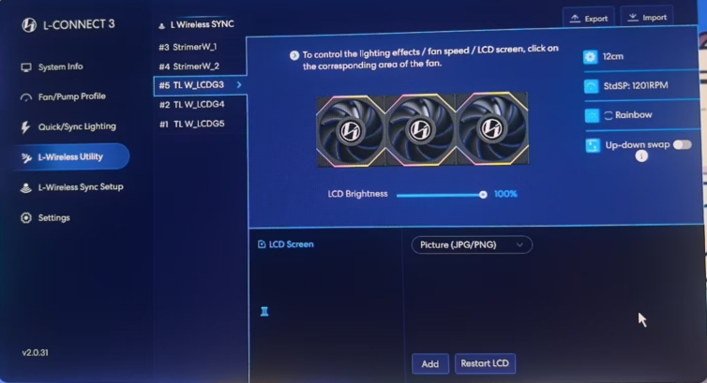

1.1 Please reinstall the latest version of L-Connect 3.

If you have already uninstalled and reinstalled the software but the issue persists

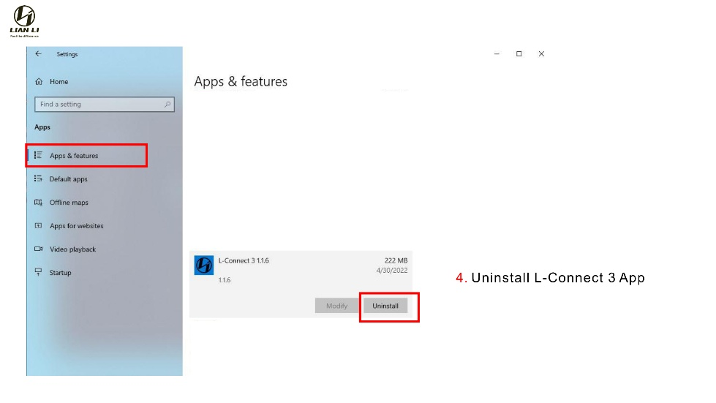

1.2 Disconnect the fan’s USB cable, clear USB device history , shut down your PC, reconnect the USB cable, and then power on the system (detailed steps below):

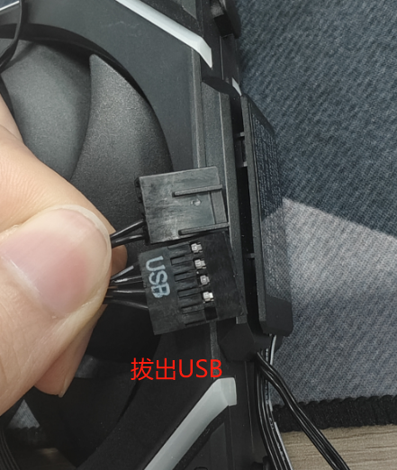

Unplug the USB cable

**Download Cleanup tool:** <https://drive.google.com/file/d/1mlBsMDQ0J4302F5dK9XHcCLmMk2jmoLL/view?usp=sharing>

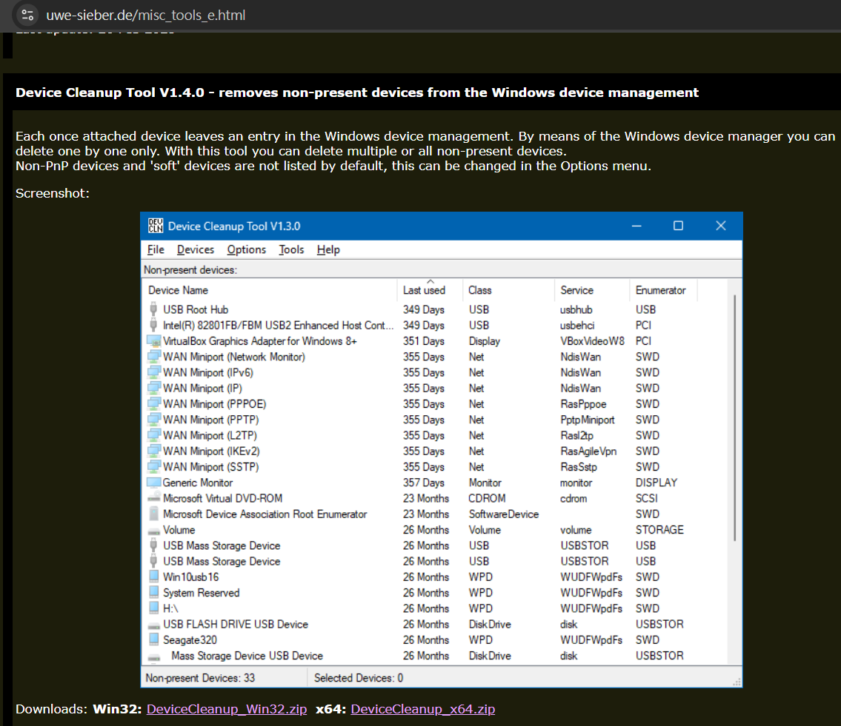

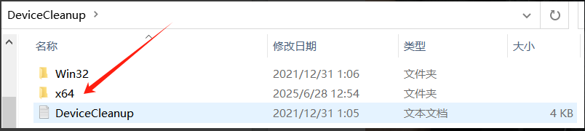

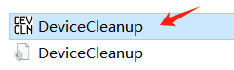 **Right-click and run as administrator**

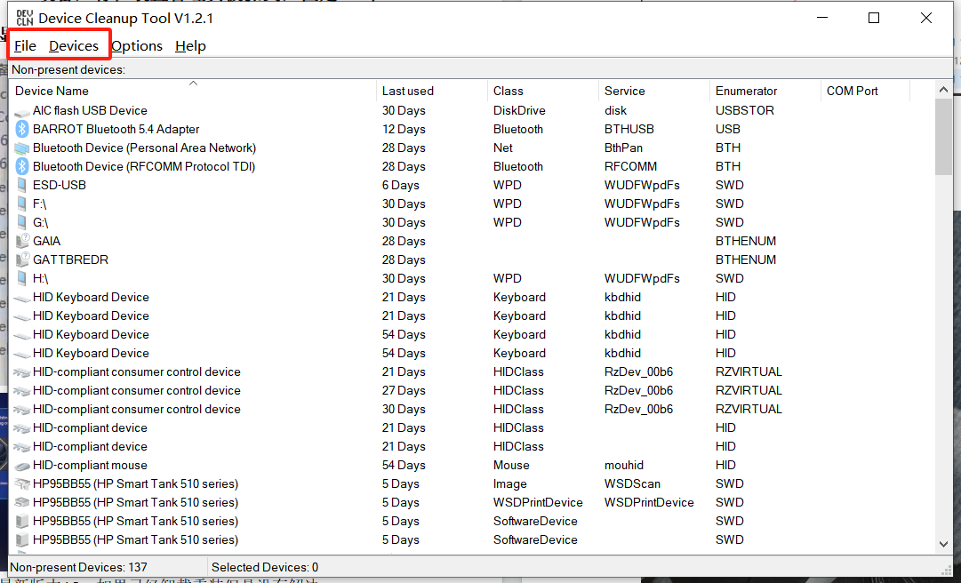

**Navigate to the "Devices" tab – select all – click "Remove selected"**

**1.3 At this stage, most users should be able to resolve the issue.**

If the problem still exists, open Device Manager and manually uninstall the LCD device to allow the system to rescan the USB hardware (detailed instructions below). This step helps rule out any USB path conflicts that might prevent L-Connect 3 from initializing the device properly.

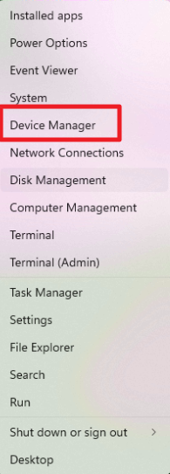

**Right-click the Windows Start menu to open Device Manager**

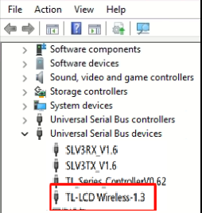

**Under “Universal Serial Bus controllers,” locate the LCD device, right-click and uninstall.**

**1.4** Open the Windows Control Panel, go to Power Options – System Settings, and disable Fast Startup. This ensures the USB device is fully shut down during power off, allowing its complete reinitialization on reboot.

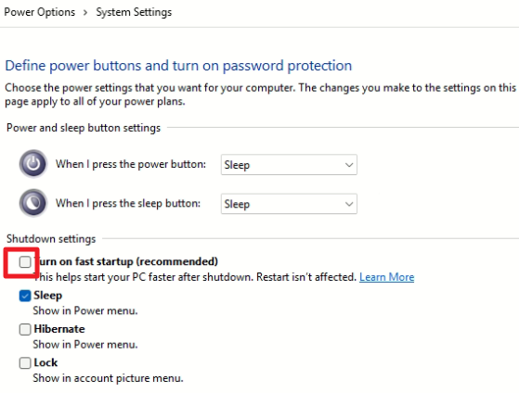

1.5 Power off the system, unplug the power supply, and wait until there’s no residual power. Then power on again to allow the USB device to be freshly recognized.

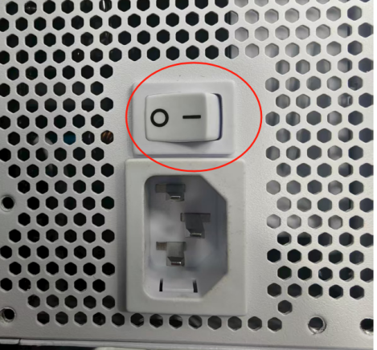

Fully shut down and disconnect power to ensure a complete reset